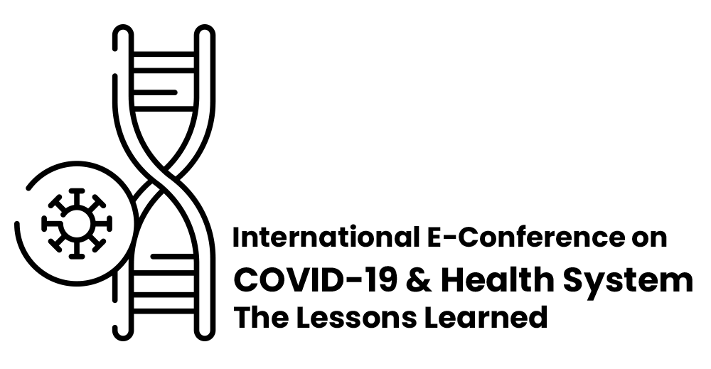

Registration and Participation Guidelines
Registration
Conference registration opens in 19th Feb, 2021 and the registration deadline will be 12th May, 2021. Before submission, the registration in the conference website is mandatory.
Steps to registration:
To register in the conference please follow the instructions below:
- Visit the conference website at http://covid19.zums.ac.ir/. Select the language using the conference membership menu, tap the option “register” and fill in the requested information.
- Activate the link sent to you in your email. (Note: If you have not received link in your email, please be sure to check your junk/spam folder.)
- In the login section of the conference website, enter your username (your email) and password.
- Logging into the system and user panel is only possible using the same language at the time of registration.
- Registration, submission of abstracts and participation in the conference are all free of charge.
Submission
To submit an article after registration in the website and preparation of your article according to the formatting guidelines provided on the first page of the conference website, use the menu "Join the conference" and then select "Download file". To this end, use the following instructions:
- Use your username and password to gain access to the user panel. Click on the "Submit article" menu.
- In the "Submit Article" menu, and “submitting a new article”, upload English abstract file of your article in docx, doc or zip format with a maximum size of 4.5 MB, and then complete the other requested information in the form. (Note that in this section you are only asked for the English abstract file of the article).

Important Notes:
- Authors should submit the English abstract of their article according to the requested format on the website.
- If the English abstract contains serious spelling or grammatical mistakes, it will be eliminated and will not be considered in the reviewing process. Therefore, it is strongly advised to tackle all such writing problems in your abstract before completing your submission.
- While submitting the abstract of your research article, make sure of the proper use of institutional affiliations and the email address of all co-authors. Otherwise, the abstract will not undergo reviewing process.
- The conference secretariat will only correspond with the author in charge of the article (only one person). The certificate will be issued only to the author in charge of the article. However, the names of all contributors will be mentioned in the certificate. If the author in charge for the article is not clear, the certificate will be issued with the name of the first author.
- After submission, it is not permitted to change the names or the order of the authors.
- Abstract should be submitted in “doc” or “docs” format using Microsoft Word Software 2007 or later versions.
- If the abstract is not prepared according to the specified format, it will be excluded from the reviewing process.
• Changing or recovering the password in the user panel

To define a new password, tap the “Password Change” menu icon in your user panel and change your password.
Resetting a forgotten password

A new password is sent to your email after filling the password recovery or password reset form.

Please note that:
- A secure password is one that includes letters, numbers, and symbols, such as: kdT@28.

Reviewer’s Guidelines:
      - Register as a reviewer by using “reviewer’s panel” menu in the conference website.
      - To enter your panel, your account must be activated by the website administrator.
      - Please be careful in choosing a secure password. A secure password is one that includes letters, numbers and symbols, such as: aM5@y3.
      - Upload your resume in a ZIP or RAR format. It is not possible to upload the resume file in the format of PDF, word, etc.

